

PIK3CA (E545G)
Catalog Number: CR-M26208
Gene Symbol: PIK3CA, CLOVE, CWS5, MCAP, MCM, MCMTC, PI3K, p110-alpha
Description: Anti-PIK3CA (E545G) Mouse Monoclonal Antibody

Background: Phosphatidyl 3-kinases (PI3K) are a family of lipid kinases involved in many cellular processes, including cell
growth, proliferation, differentiation,
motility, and survival. It is composed of an 85 kDa regulatory subunit and a 110 kDa
catalytic subunit. Mutants of PIK3CA has
been found in the pathogenesis of several cancers, including colon cancer, gliomas, gastric cancer, breast cancer, endometrial cancer, and lung cancer.
Immunogen: A synthetic peptide from the
internal region of PIK3CA which includes the mutation of E545G, human origin.
Tested applications: ELISA, WB, IHC Recommended dilutions:
ELISA: 1:1000-1:5000
WB: 1:500-1:1000
IHC: 1:50-1:100
Concentration: 1 mg/ml
Host: Mouse
Clonality: Monoclonal
Purity: Purified from ascites
Format: Liquid Storage buffer:
Preservative: no
Constituents: PBS (without Mg2+ and Ca2+), pH 7.4, 150 mM NaCl, 50% glycerol
Species Reactivity: Recognizes E545G mutant, but not wild-type PIK3CA of vertebrates.
Storage Conditions: Store at -20°C. Avoid freeze / thaw cycles.

Western blot:
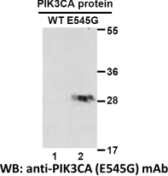
Western blot analysis of recombinant PIK3CA (E545G) and wildtype proteins. Purified
His-tagged PIK3CA (E545G) protein (lane 2) and corresponding wildtype protein (lane 1) were
blotted with anti-PIK3CA (E545G) monoclonal antibody (Cat. #26208).

For research use only. Not for diagnostic or therapeutic applications.

Immunofluorescence:
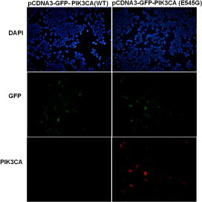
Immunofluorescence of cells expressing
PIK3CA proteins with anti-PIK3CA (E545G) antibody. HEK293T cells were transfected with pCDNA3-GFP-PIK3CA (WT) plasmid (left
column) or pCDNA3-GFP-PIK3CA (E545G)
plasmid (right column), then fixed and stained
with anti-PIK3CA (E545G) monoclonal antibody (Cat. #26208).

科博瑞（武汉）生物科技有限公司
TEL：027-87615885 15972062685
- mail：3636901710@qq.com
Web:www.coburybio.com

